**I am Swapnadeep Das, a UI/UX/Web Designer. I am passionate about creating usable digital products.**

**UI Design:**

Once the usability issues were resolved, I moved on to design the final screens. My goal was to create a visual identity that aligned with the brand’s values and message, which is: the *“brand motto”*. Also, I’ve checked the competition and taken a deep dive into my catalog of references for inspiration.

* The visual style I followed is Fresh because it looks more attractive.
* I have followed the popular guidelines of iOS Style guide.
* I have used the designing tool Photoshop.
* The users can book the availability of the rooms, can check prices, and can book a room.

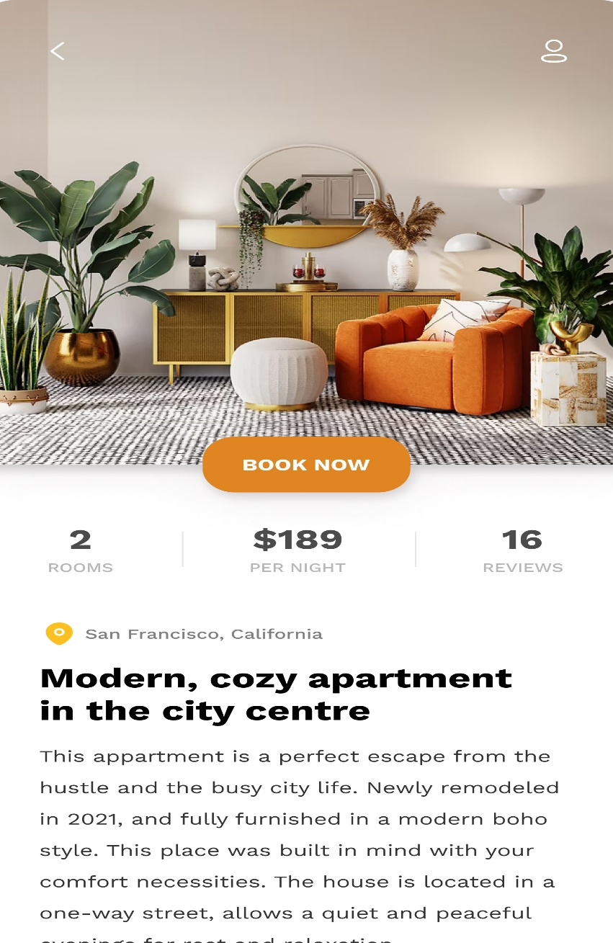

### UX Designing Wireframes:

I translated my first sketches into low-fidelity wireframes. Then, I improved them by adding a few relevant stock images and copies provided by the marketing team. At this stage, the wireframes were defined enough for some user testing. Based on 4 tests, I’ve made a few alternations and moved on to creating high-fidelity prototypes.

* I have created high-fidelity wireframes.
* I have used the Balsamiq tool for wireframing.
* I had undergone some wireframe user testing by putting those wireframes in front of actual users and getting their feedback.
* I made six iterations.

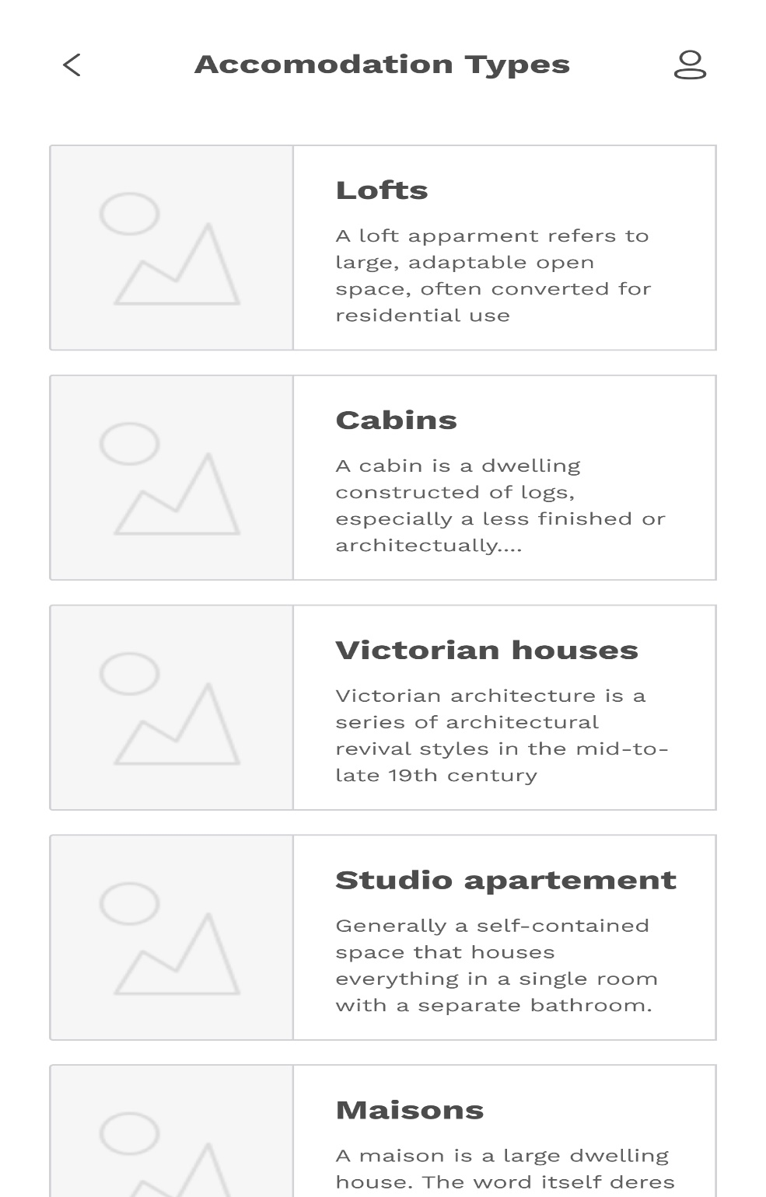

### Sketches:

I began the design process with low-fidelity sketches and wireframes to accelerate decision-making through visualization without losing time. My sketches were based on the initial user interviews, the business goal, and the heuristic evaluation. They each pointed to the fact that there were too many distractions in the flow. We came back to the sketches throughout the entire design process to make sure that we don’t lose sight of our primary goals and ideas.

* The main purposes of my sketches were presenting, testing, and brainstorming.
* My sketches helped to move forward in Research, Information Architecture, Wireframing, Prototyping, and Visual Communication.